**COURSE RECOMMENDATION SYSTEM**

A Project Report

Submitted for the partial fulfilment for the award of the degree of

**B. TECH. CS/IT 3RD YEAR**

Submitted by: BTCS_G31

Anushka Singh(2016718)

Manasvi Chaturvedi(2016185)

Nupur Pancholi(2016213)

Priya Agarwal(2016236)

Under the Supervision of

Name of the Mentor Name of the Coordinator

Dr.Dipanwita Thakur Prof. Saurabh Mukherjee

(Assistant Professor) Dr. Neelam Sharma

Banasthali Vidyapith Dr. Pooja Asopa

(Assistant Professor)

Banasthali Vidyapith



**Department of Mathematics & Computing**

**Banasthali Vidyapith**

**Banasthali – 304022**

**Session : 2022 – 2023**

**Certificate**

Certified that Anushka Singh, Manasvi Chaturvedi, Nupur Pancholi and Priya Agarwal have carried out the project work titled “Course Recommendation System“ from 17-12-2022 to 12-04-2023 for the award of the B. Tech. CS/IT 3rd Year from Banasthali Vidyapith under my supervision. The thesis embodies result of original work and studies carried out by Student herself and the contents of the thesis do not form the basis for the award of any other degree to the candidate or to anybody else.

Dr.Dipanwita Thakur

Designaton: Assitant Professor

Place: Banasthali Vidyapith

Date: 12-04-2023

**ABSTRACT**

Recommendation system is an ongoing research that is applied in various domains. Students are often confused when it comes to choosing a particular course. Since there are many elective courses in each semester, students have to spend a lot of time exploring those courses, and they may not be able to explore all of them and many times they are unable to choose one based on their interest. Therefore, our system focuses on designing and developing the recommendation system that is able to recommend elective courses for university students and to assist them to make the correct decision for enrolling in that course for that semester. It recommends the courses based on the similarity between the course templates of students. The recommendation system is developed to provide aid to students in suggesting suitable courses for them as well as reducing time to explore courses that they will take. Apart from assisting the student, recommendation systems could help the university also, by suggesting courses for the student based on interest, current trend, and need.

**ACKNOWLEDGEMENT**

We would like to extend our sincere and heartfelt thanks towards God. We extend our gratitude towards our university, Banasthali Vidyapith and our project coordinators who guided us throughout in making our project.

We would also like to express our special gratitude towards our university Banasthali Vidyapith for providing us this opportunity to be able to work on this project and learn a whole new set of skills in the given constraints. Also, we were able to work together as a team with their support and unmatched guidance.

We would also like to sincerely thank our mentor, Dr.Dipanwita Thakur for her moral support and guidance during the tenure of our project. Without her active guidance, help, cooperation and encouragement, we would not have been able to present our project on time.

We also acknowledge with a deep sense of reverence, our gratitude towards our parents and family members for their valuable suggestions in completing the project.

Lastly, we would like to show our gratitude towards each other for our dedicated cooperation in developing the project.

**TABLE OF CONTENTS**

* Introduction
* Required Analysis (SRS)
* Product Perspective
* Product Function
* Hardware Interfaces
* Software Interfaces
* Communication Interfaces
* User Characteristics
* General Constraints
* Technology Used
* Functional Requirements
* Non – Functional Requirements
* System Design (SDS)
* Web Architectural Design
* Work Breakdown Structure
* Work Flow Diagram
* Sequence Diagram
* Activity Diagram
* Class Diagram
* Coding
* Testing
* User Interfaces
* Appendices
* References

**INTRODUCTION**

It has always been a tough choice for students to choose the courses in different semesters where in there is the possibility to score good grades apart from the interest in the course for a future career. Banasthali Vidyapith offers a variety of disciplinary and open elective courses with mandatory courses in the final semester. Hence, choosing the courses based on the verbal recommendation from the seniors, instructors, and fellow mates becomes a hectic task. To ease this course recommendation process for the upcoming semester, we have developed a system that deploys simple yet powerful recommendation techniques such as auto-encoders, hybrid matrix factorization, and similarity-based approaches. It is a GUI-based system that takes the input of the student’s ID (roll number) (which is stored in the dataset) and the class for which the student wants to get the recommendation. Then, it outputs the top 2 courses that the student can choose based on her interest. Also, a confidence score is provided for each recommended course.

However, the project is limited for the students enrolled in B. Tech (CS/IT) courses.

**REQUIREMENT ANALYSIS (SRS)**

**PRODUCT PERSPECTIVE**

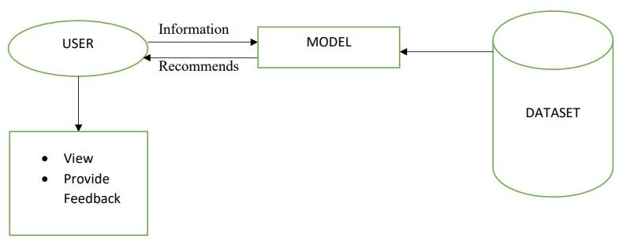

**PRODUCT FUNCTION**

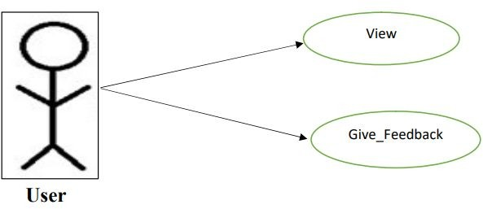

**HARDWARE AND SOFTWARE REQUIREMENTS**

**HARDWARE INTERFACE**

**Developer’s Perspective (Recommended)**

Processor – 11th Gen Intel®CoreTMi7 2.50 GHz

RAM – 4 GB

HDD – 1 TB (free space excluding data size)

**User’s Perspective (Recommended)**

Processor – Dual Core 1.3-3.4 GHz

RAM – 2 GB

HDD – 32 GB (free space excluding data size)

**SOFTWARE INTERFACE**

**Developer’s Perspective**

OS – Windows 8 and above

Mac OS 10.11 and above

Linux 14.04 and above

Tools – Visual Studio (16.11 and above)

Frontend – HTML, CSS

Backend – Flask 2.2.2 (August 2022)

Browser – Google Chrome version 109 and above

Mozilla Firefox version 79 and above

Safari version 5.1.7 and above

**User’s Perspective**

OS – Windows 8 and above

Mac OS 10.11 and above

Linux 14.04 and above

Browser – Google Chrome version 109 and above

Mozilla Firefox version 79 and above

Safari version 5.1.7 and above

**COMMUNICATION INTERFACE**

HTTP/HTTPS with TCP/IP Suite

**USER CHARACTERISTICS**

The user should have some clarity regarding their future perspective andhonestly fill the form. An unbiased selection in the form will result in the most appropriate recommendation.

**GENERAL CONSTRAINTS**

Internet connectivity

**TECHNOLOGIES USED**

Python 3.11.1

Flask 2.2.2

**FEASIBILITY STUDY**

Technical Feasibility:

The project aimed at providing an unbiased recommendation towards the inputs received from the end user based on their choice. After the completion of the project, it is evident that it can provide an unbiased recommendation to the students.

Financial Feasibility:

Our project is fiscally viable. We have been able to develop the project at zero cost at our end and have been successfully able to deploy it at no additional costs.

Operational Feasibility:

The project is fully functional and with the support and facilities provided by the organization it has been successfully completed. The team has worked together and each member is fully aware about its working.

Time Feasibility:

The project was aimed at completing in the due course of the semester from 17th December,2022 till 12th April,2023. In the given time limit, the project has been successfully completed in all respects and has been deployed.

**FUNCTIONAL REQUIREMENTS**

Defines the fundamental actions that must take place in the software for:

* + - accepting the inputs
    - processing the inputs
    - generating the outputs

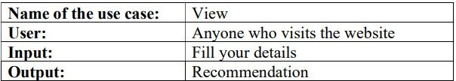

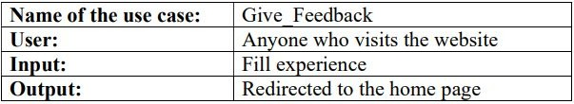

**NON – FUNCTIONAL REQUIREMENTS**

1. **AVAILABILITY**

* Dependent on the client’s Internet connection.

1. **SECURITY**

* Will prevent unauthorized attempts to access the server.
* Crucial in the web service as our dataset contains some personal information.

1. **RELIABILITY**

* A backup file is maintained so that in case of system crash, the data will not be affected.

1. **PROTABILITY**

* Since this project is a web application, it is portable.

1. **MAINTAINABILITY**

* Can be achieved by integrating new modules and upgrading the current modules at predetermined intervals.

1. **PERFORMANCE REQUIREMENTS**

* Required to make the system real time.

**SYSTEM DESIGN (SDS)**

**WEB ARCHITECTURAL DESIGN**

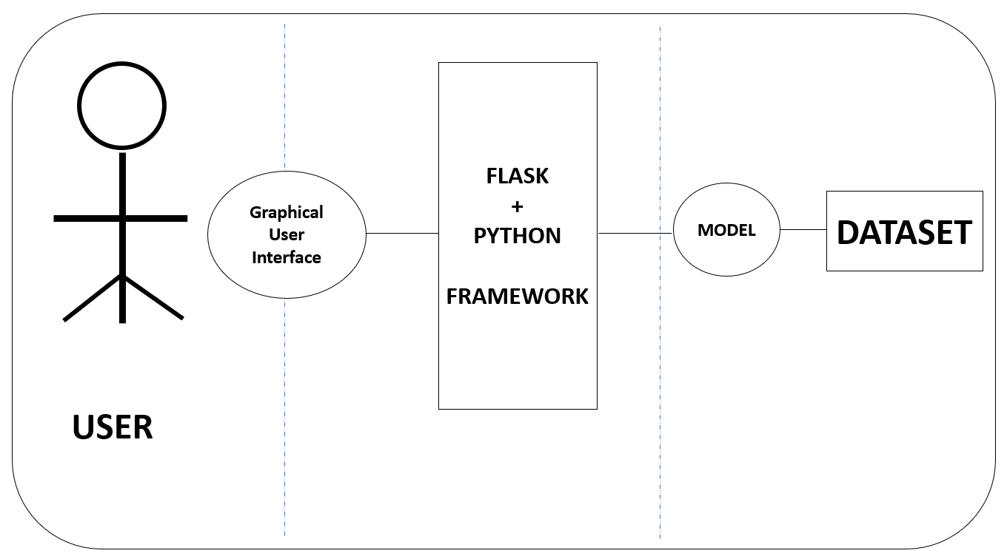

**WORK BREAKDOWN STRUCTURE**

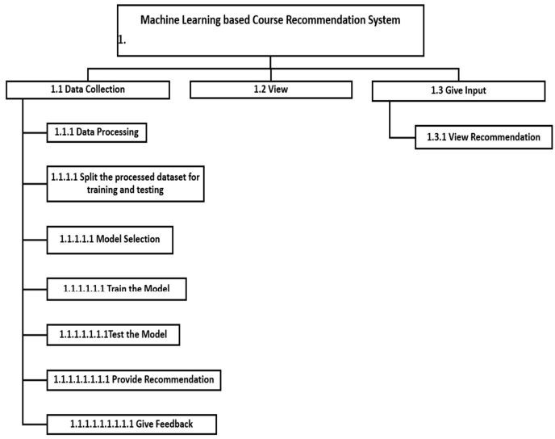

**SEQUENCE DIAGRAM**

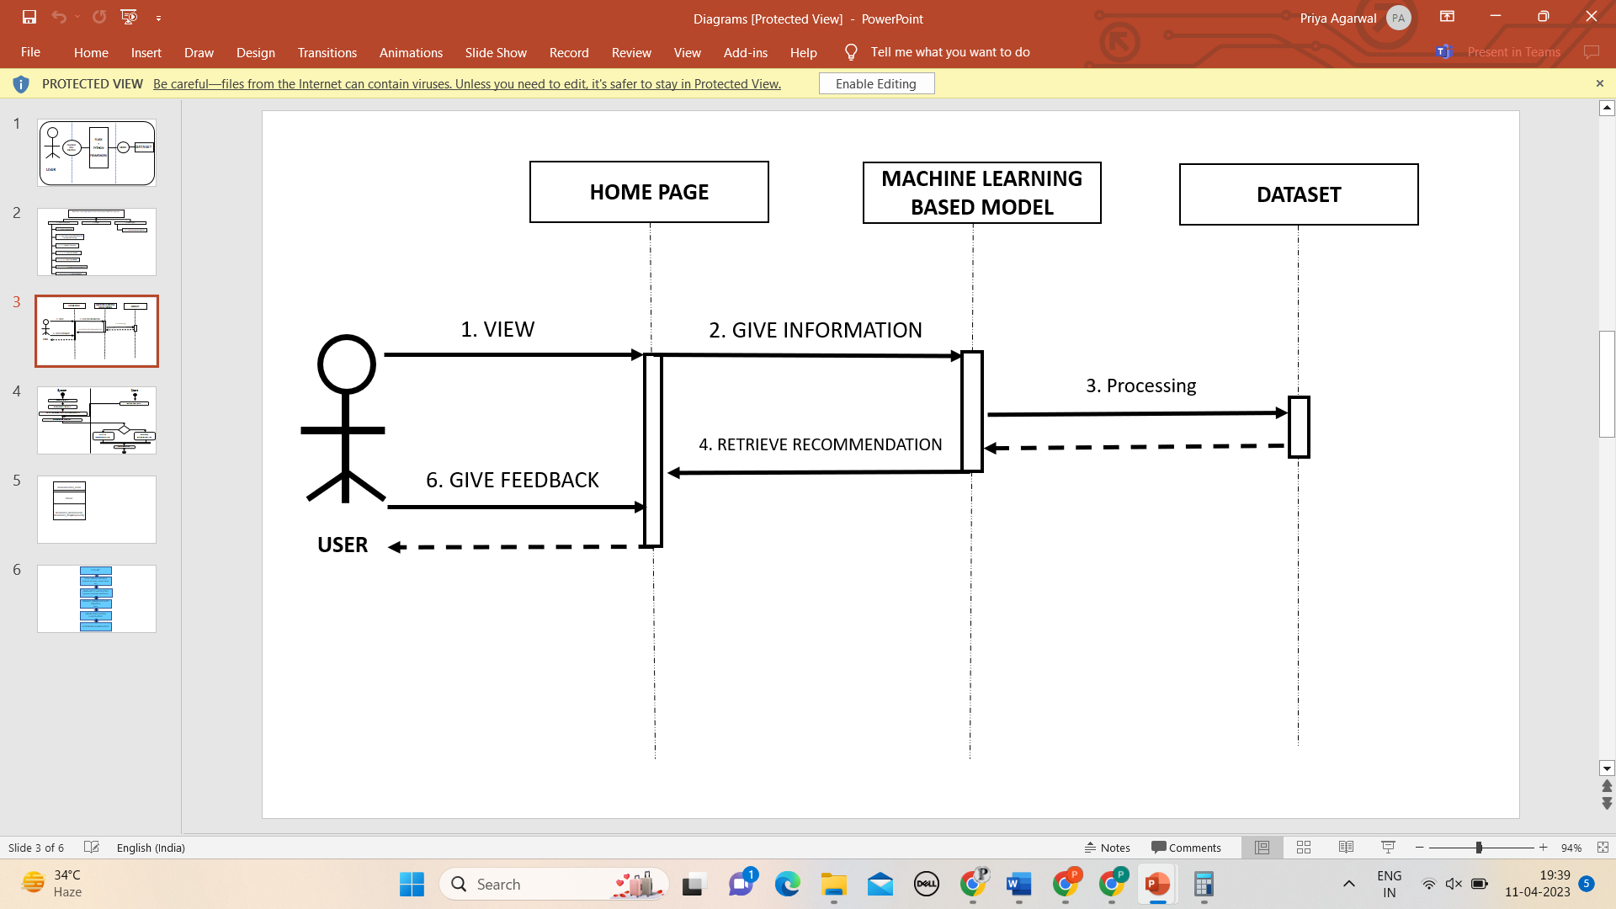

**ACTIVITY DIAGRAM**

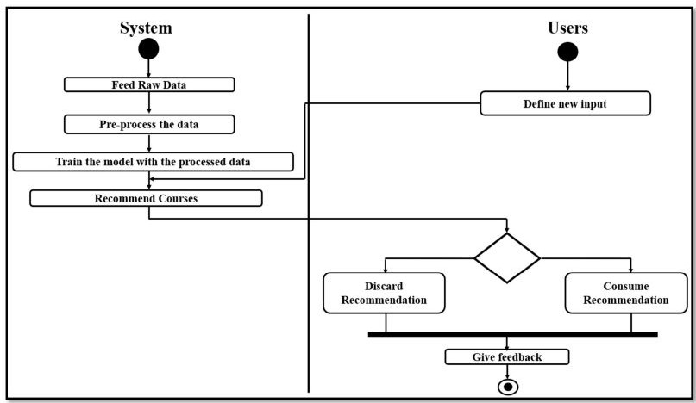

**CLASS DIAGRAM**

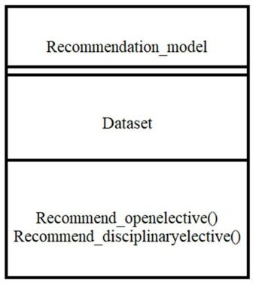

**CODING**

MODEL READING ELECTIVES:

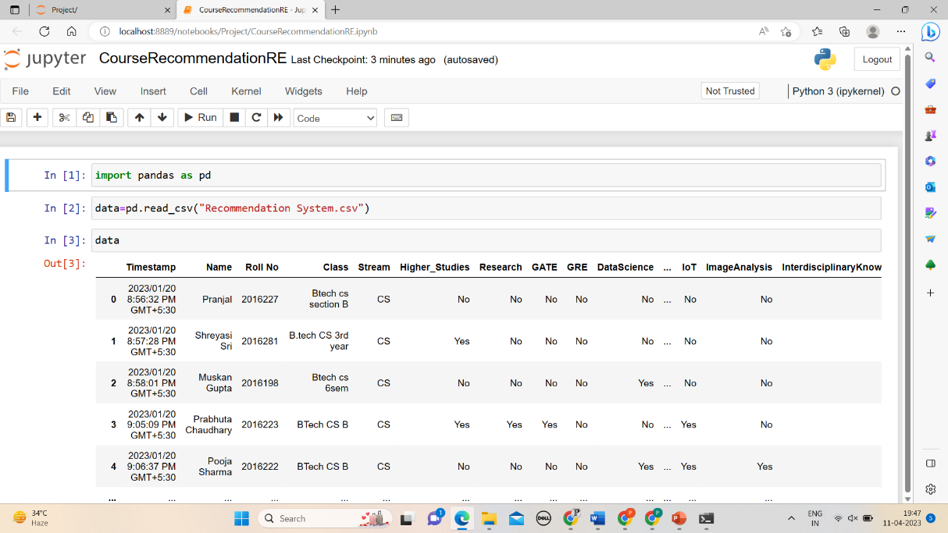

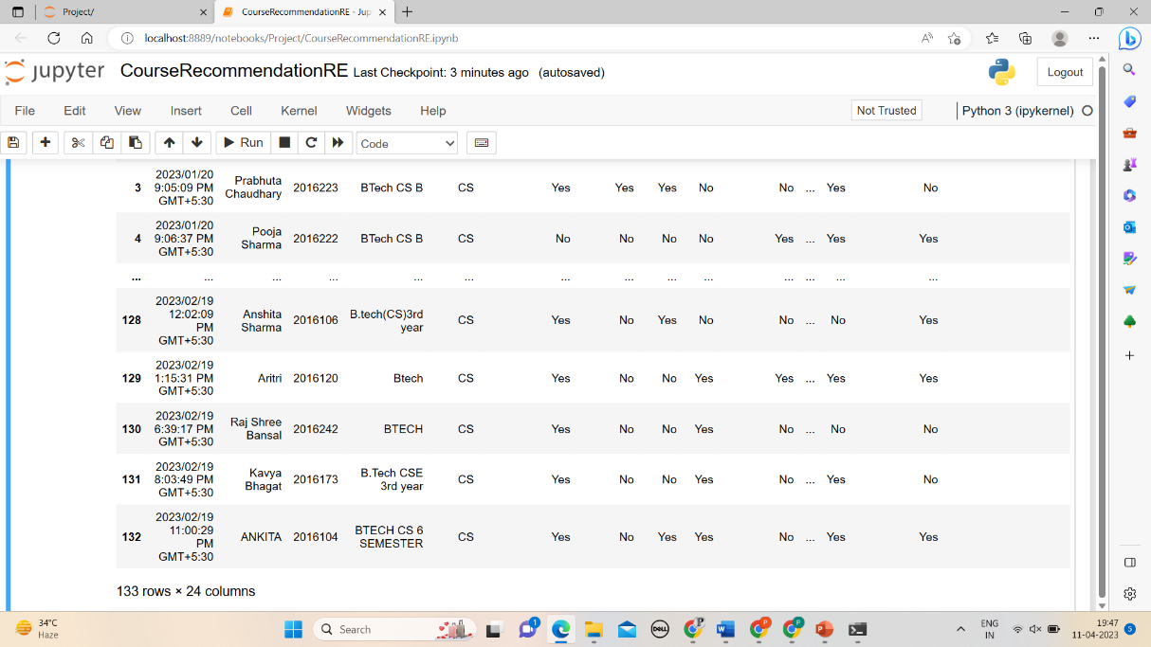

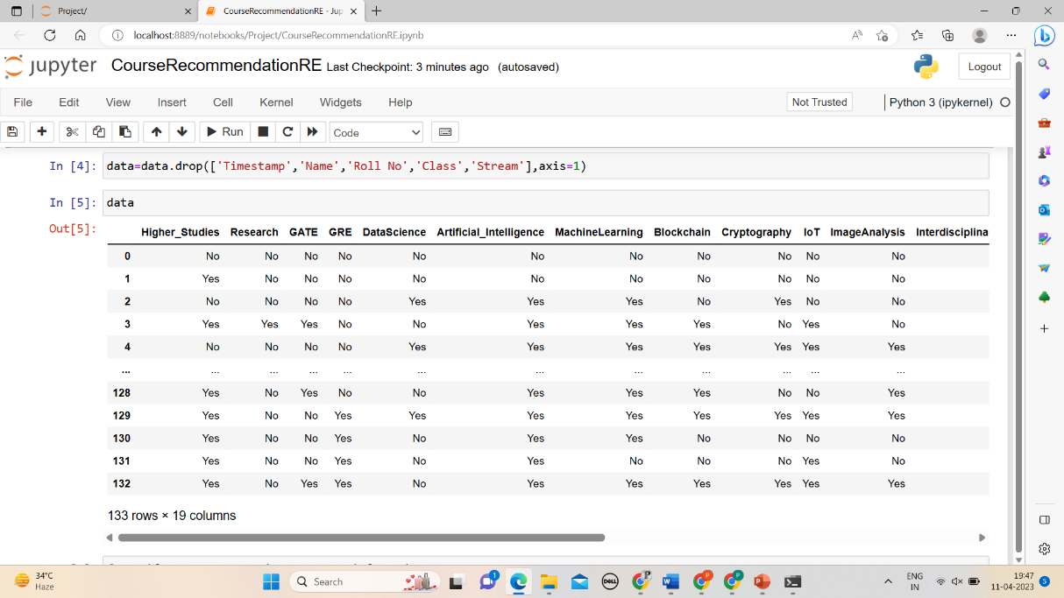

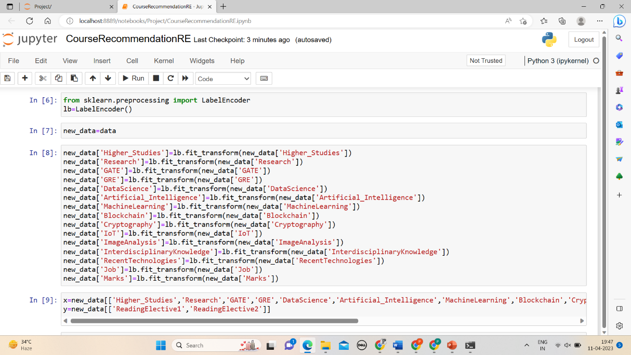

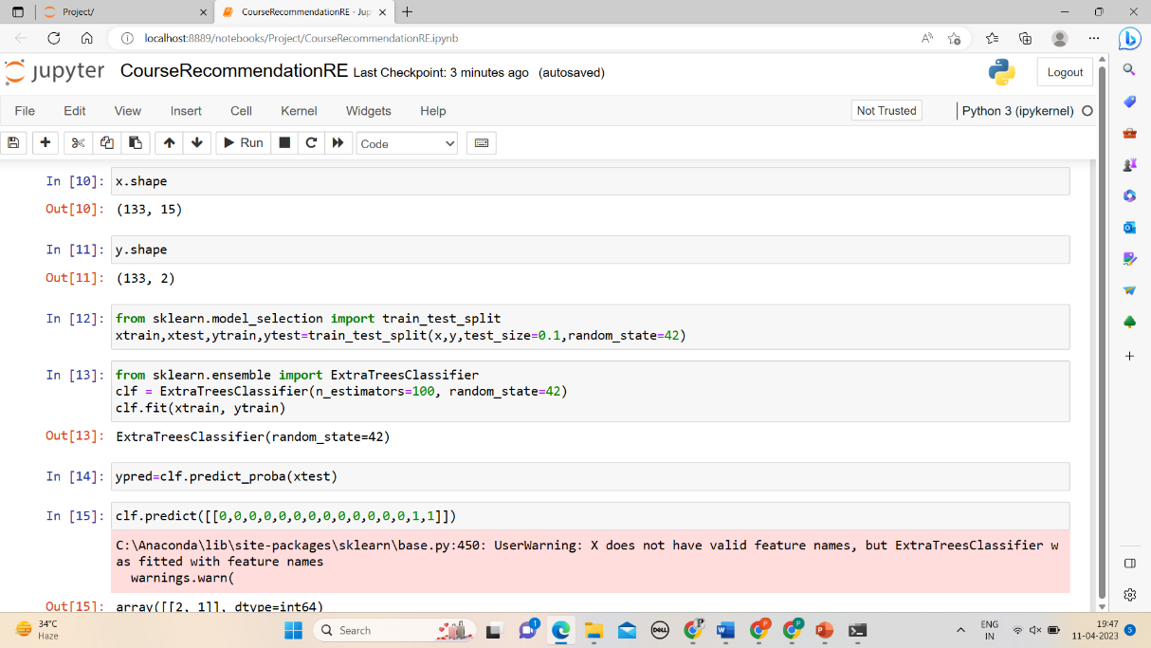

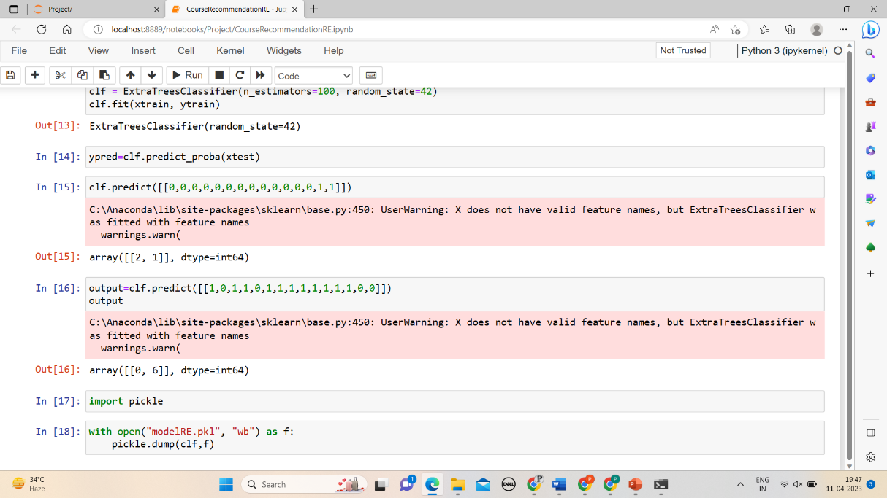

MODEL DISCIPLINARY ELECTIVES:

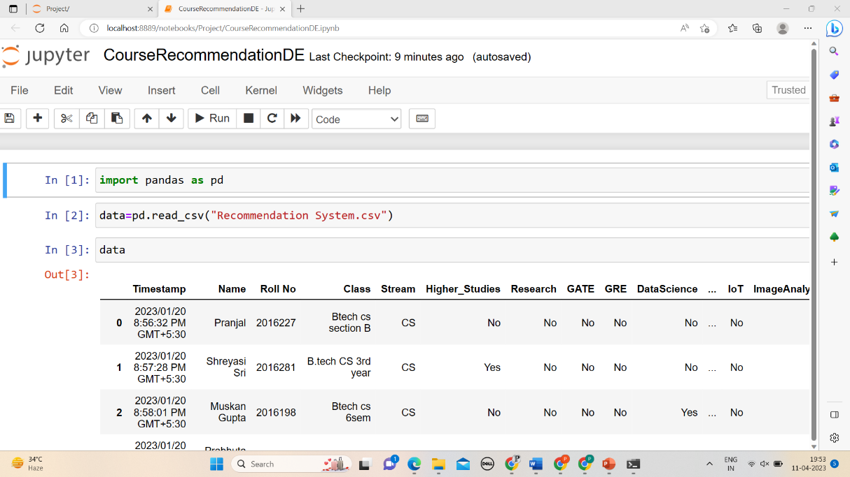

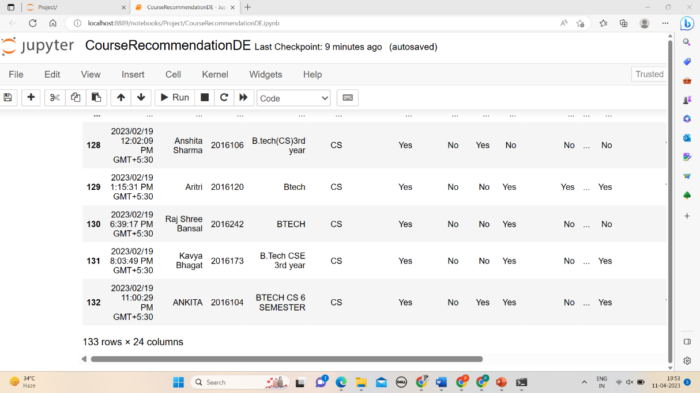

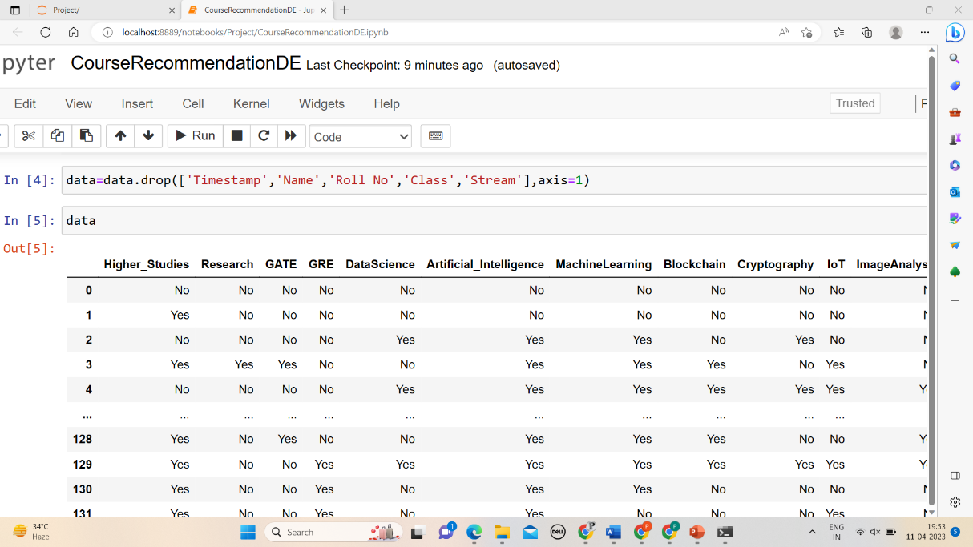

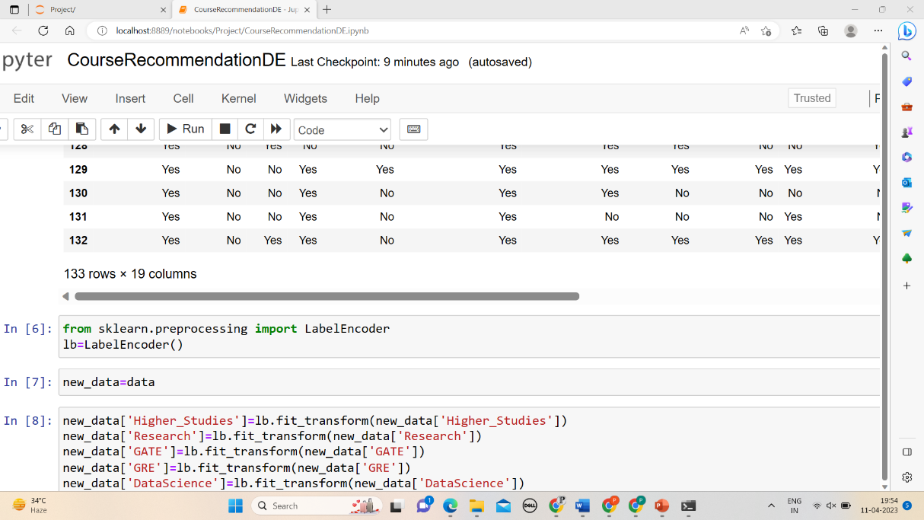

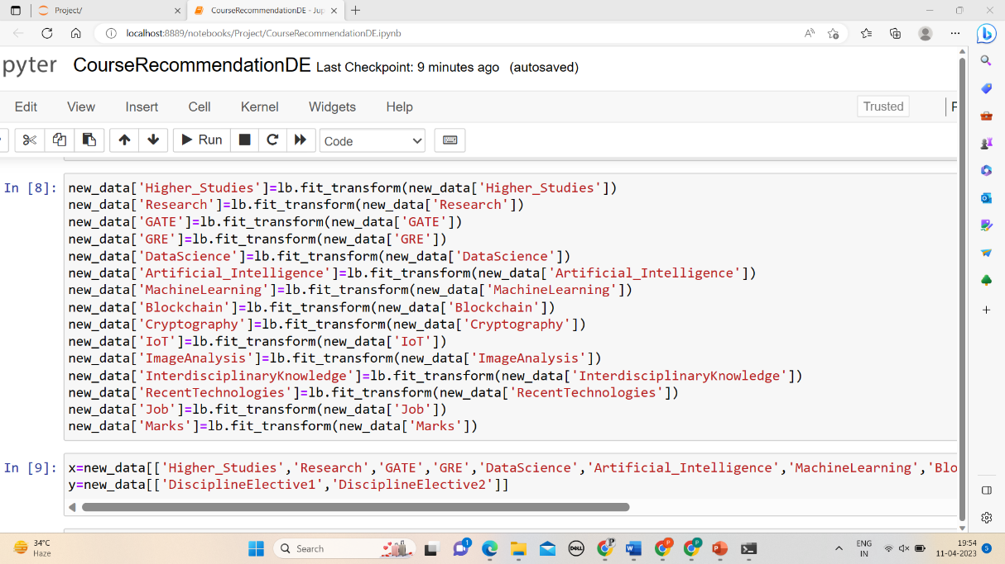

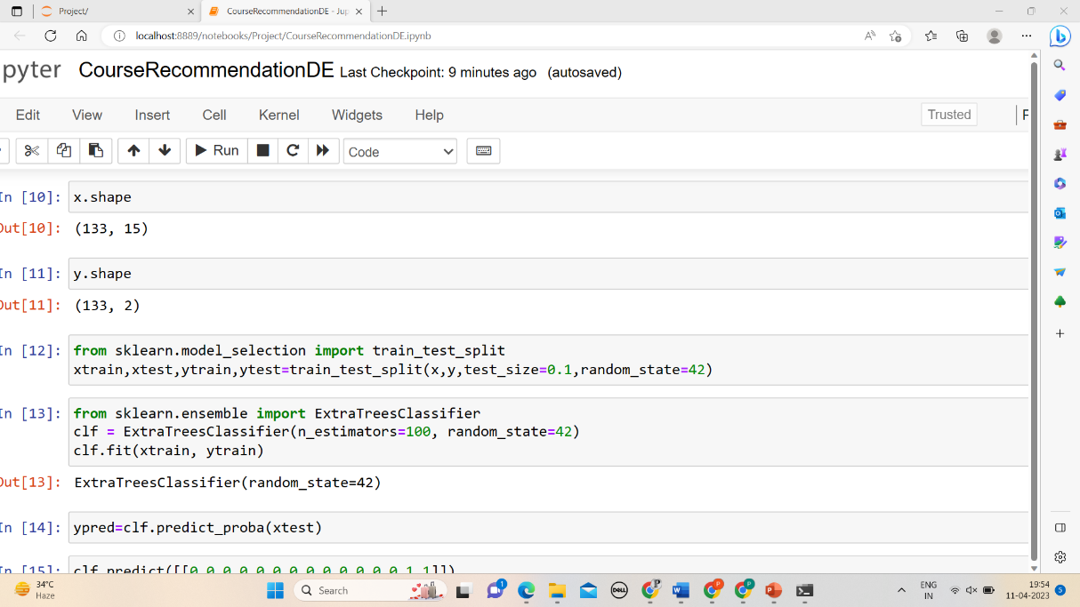

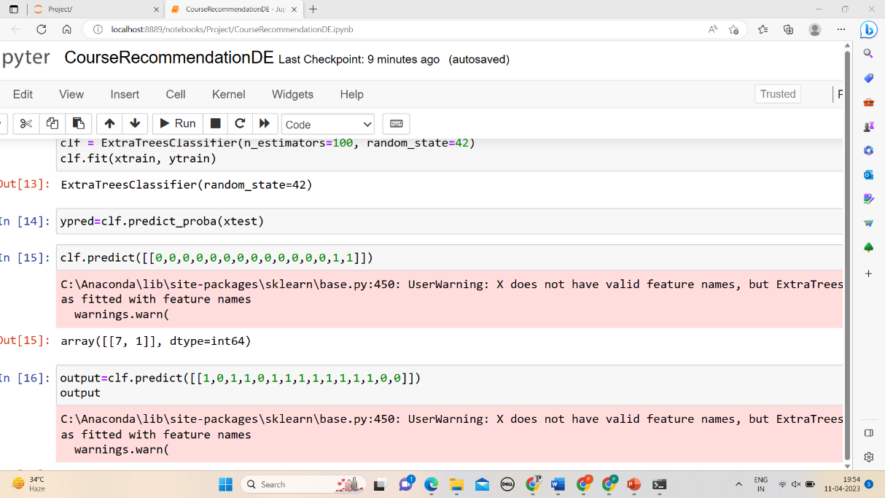

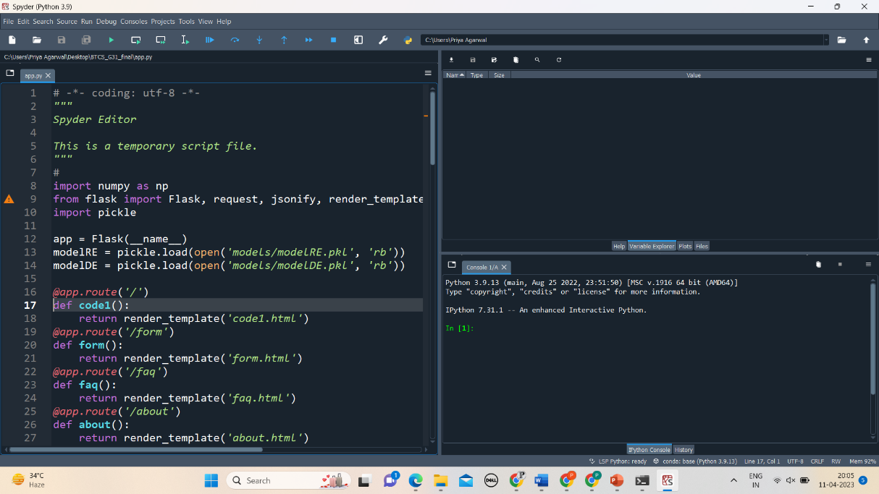

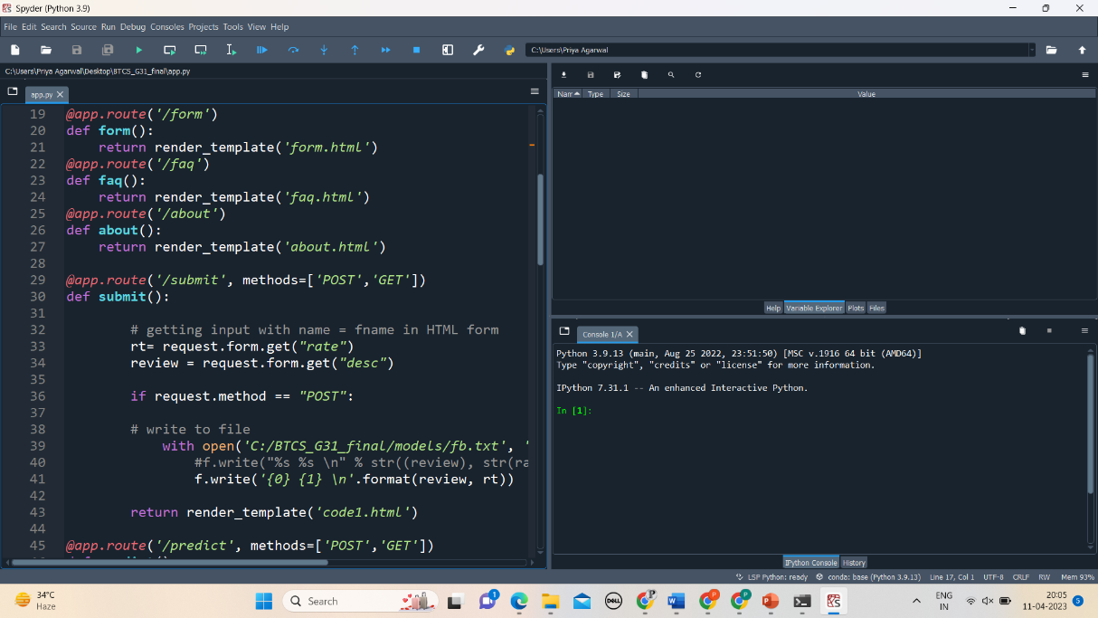

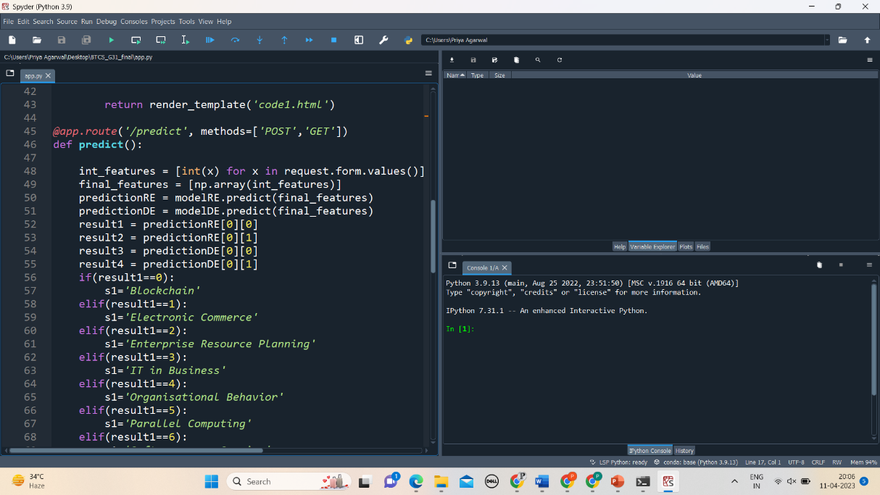

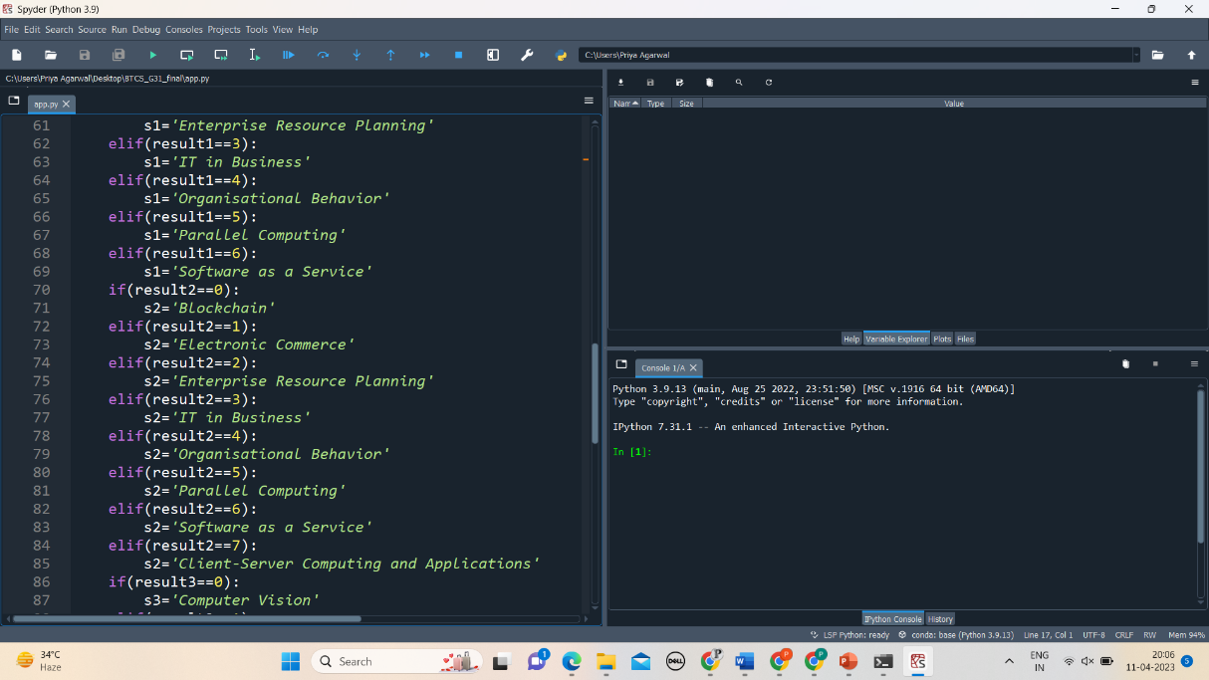

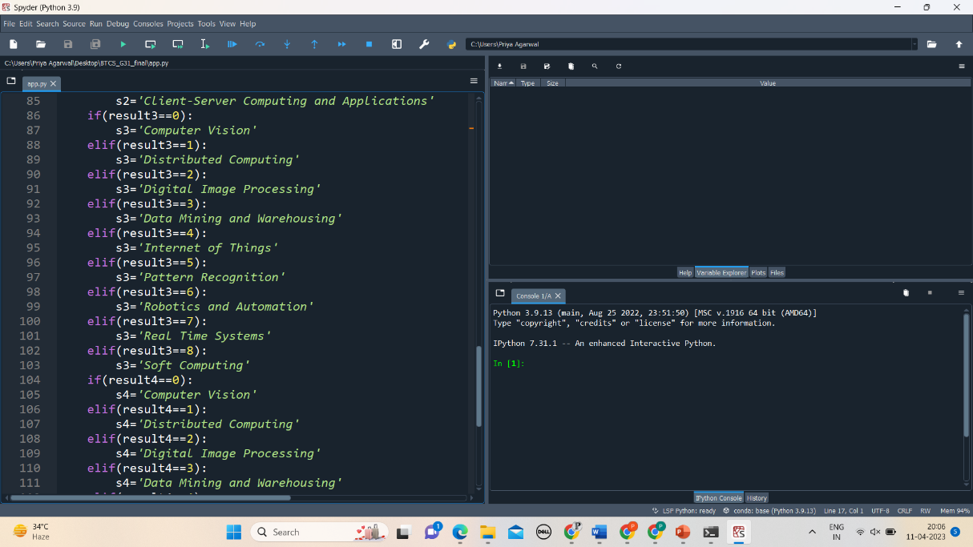

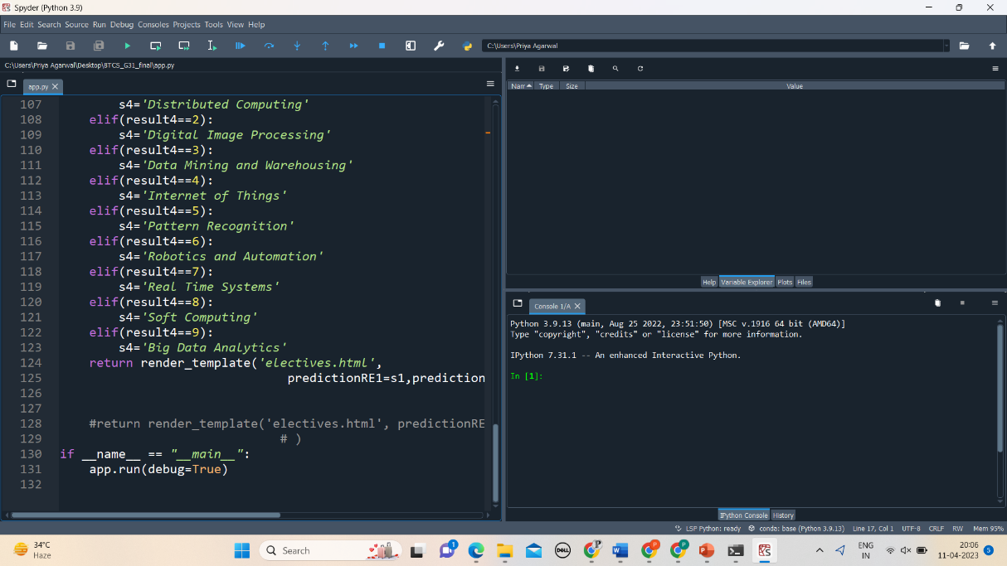

**TESTING**

Test Cases

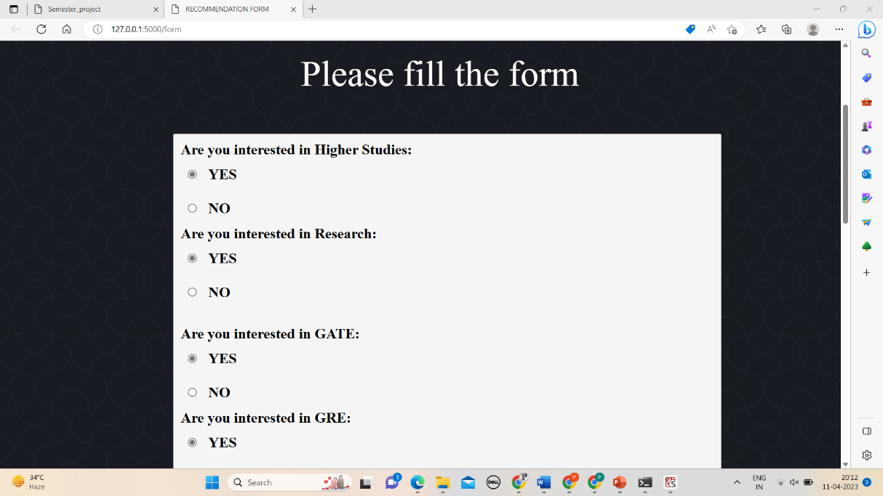

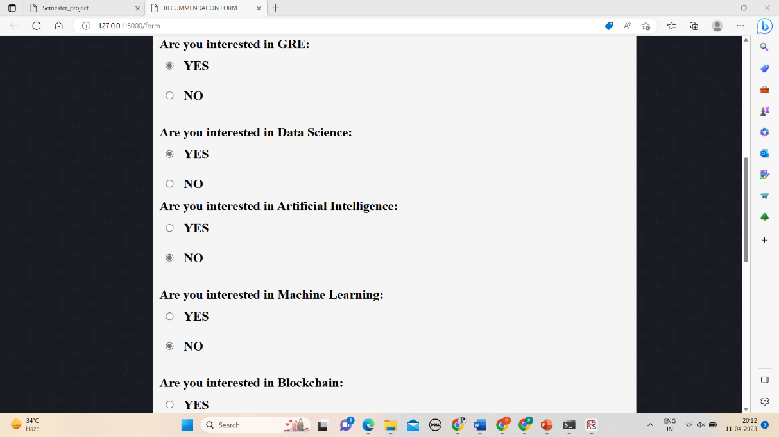

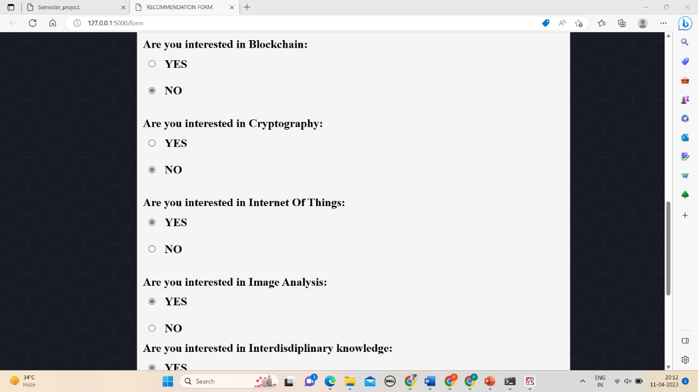

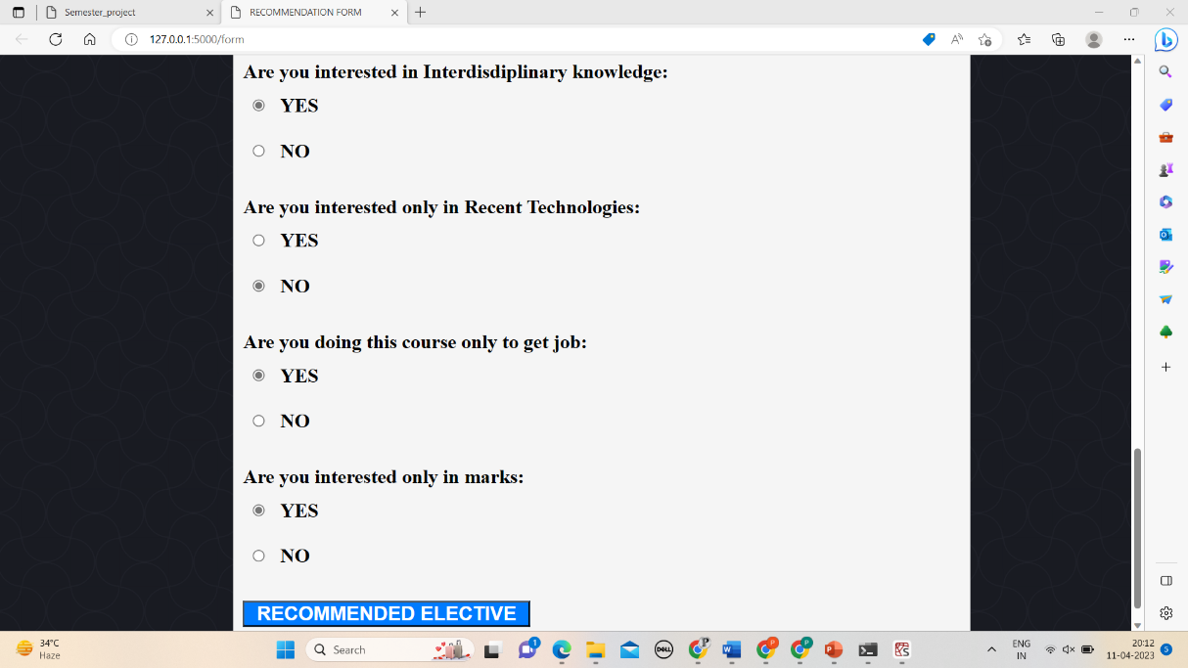

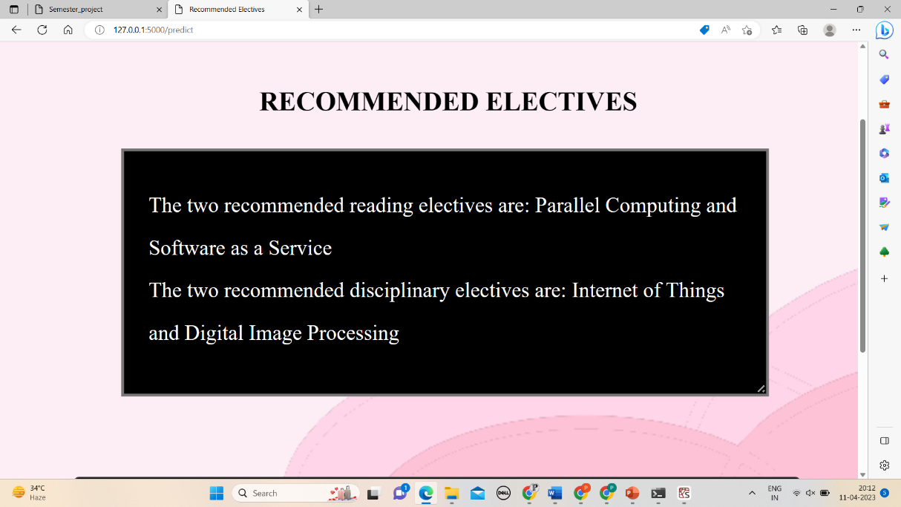

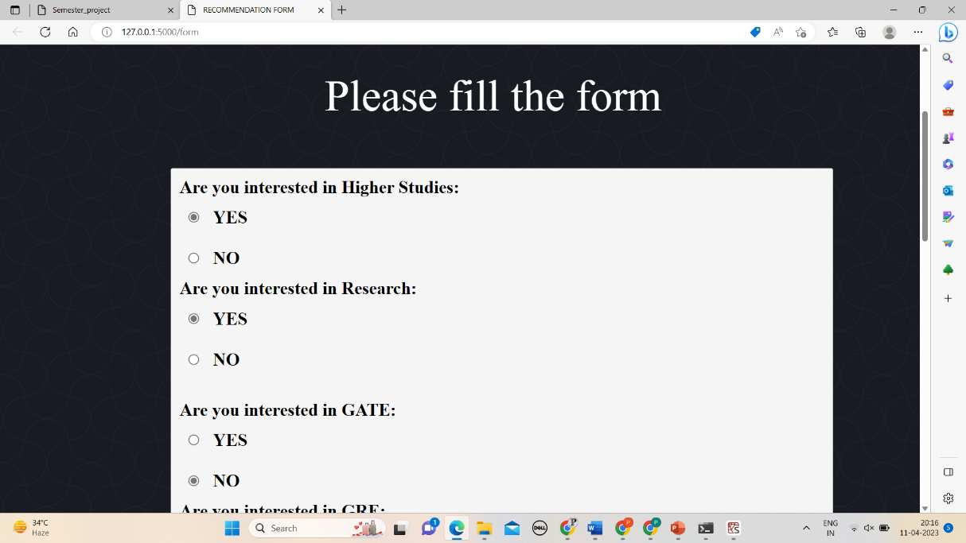

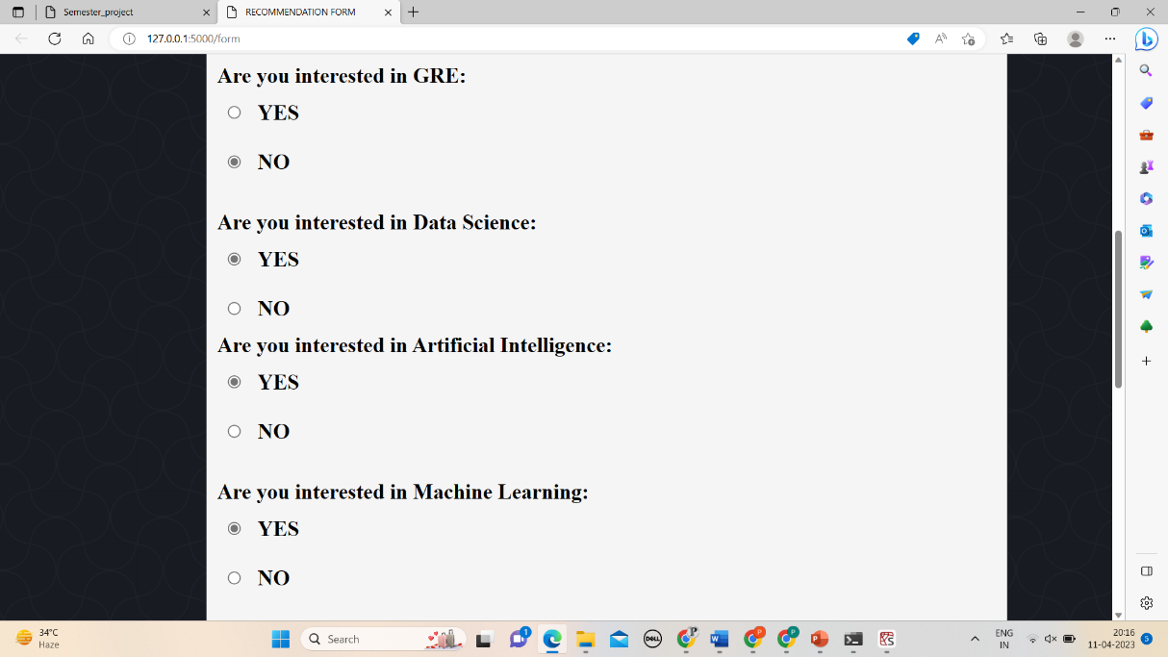

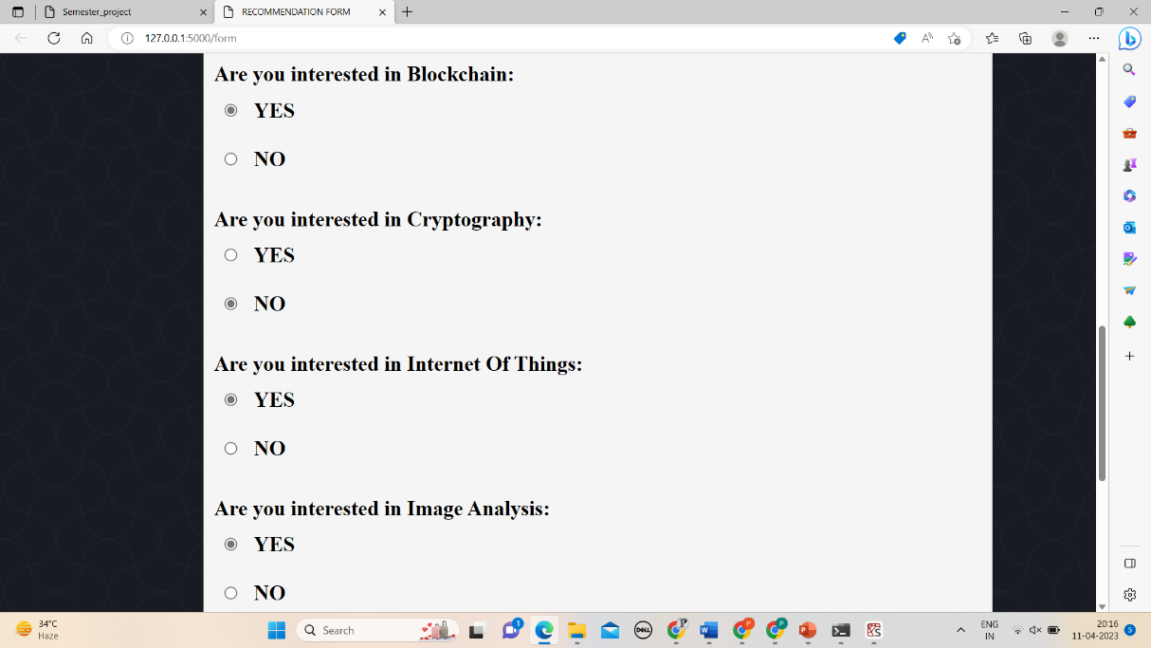

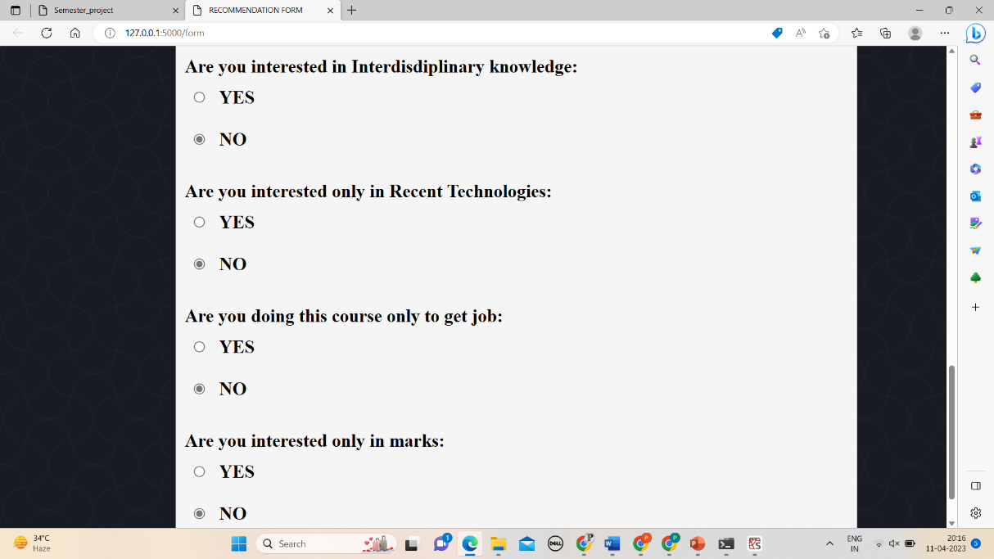

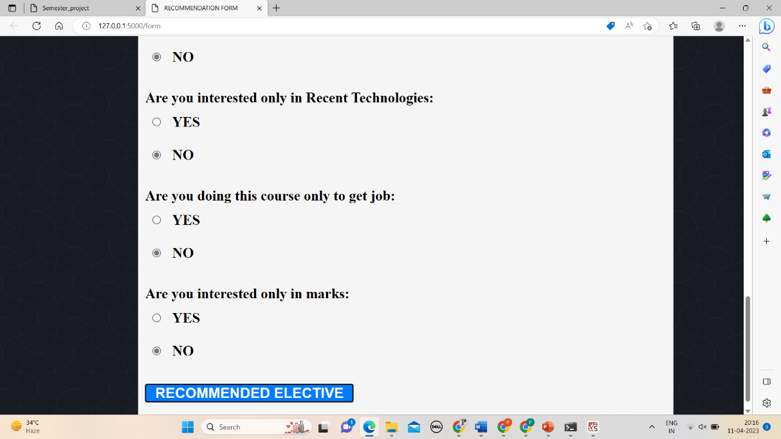

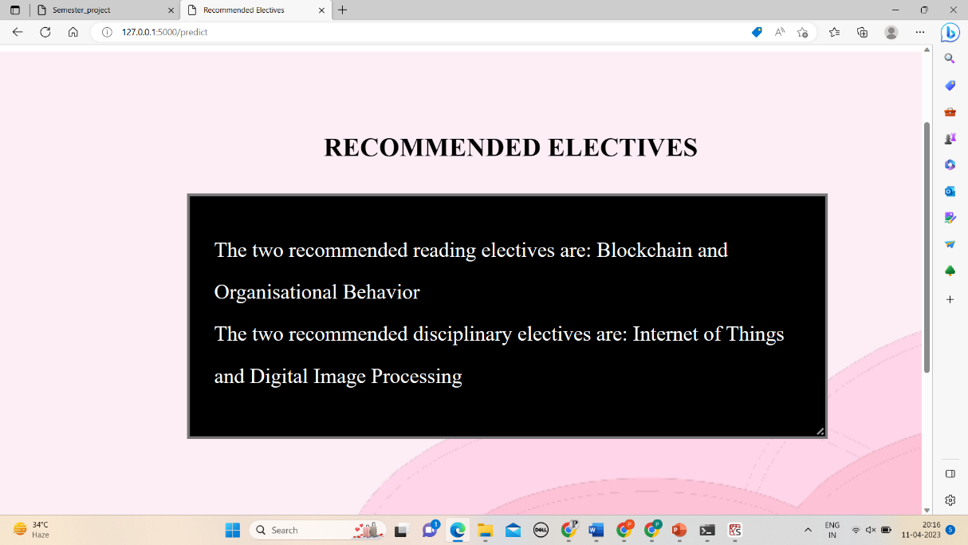

**USER INTERFACE**





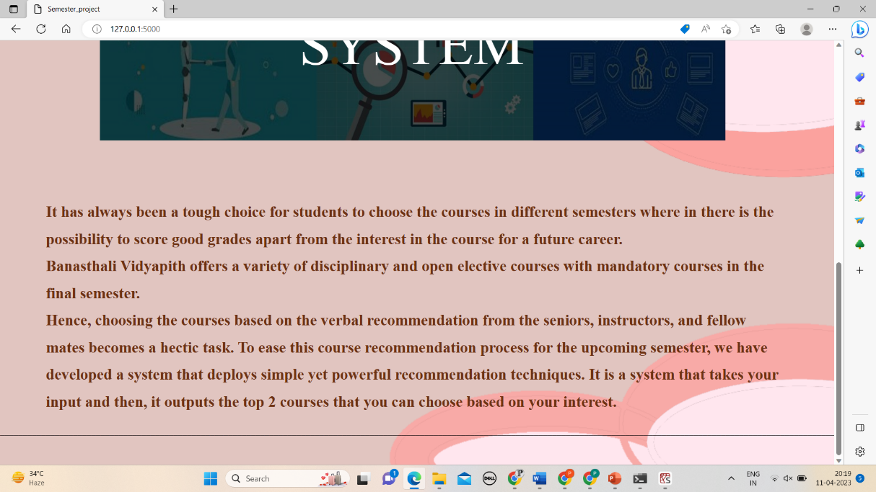

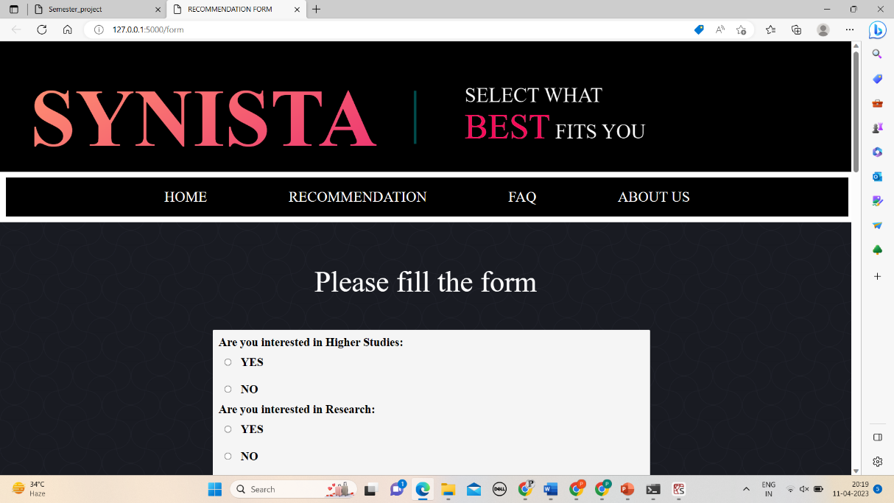

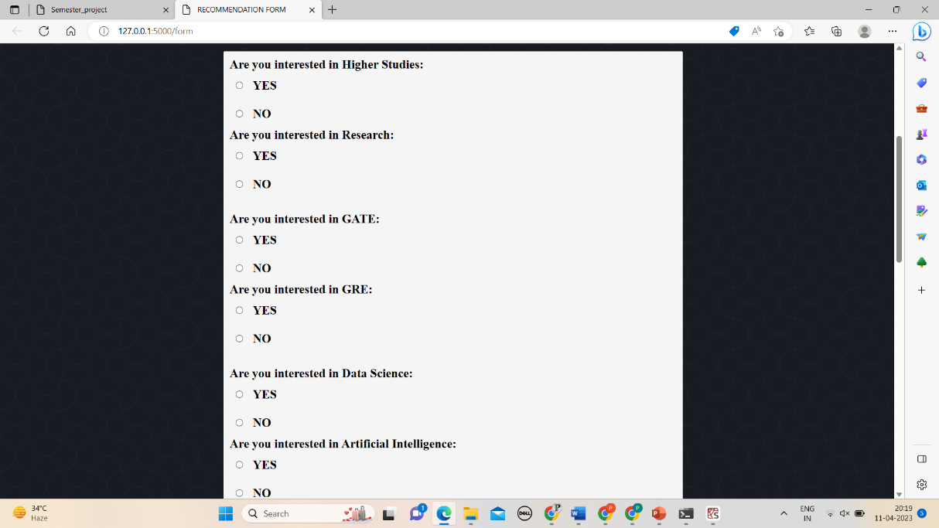

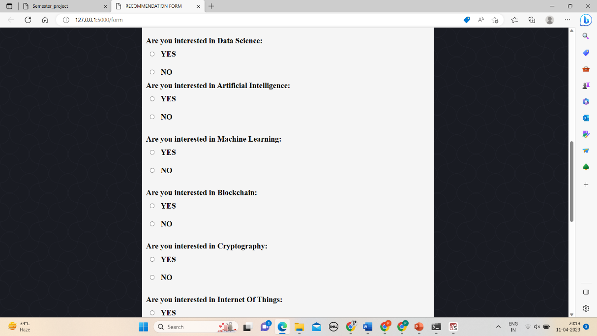

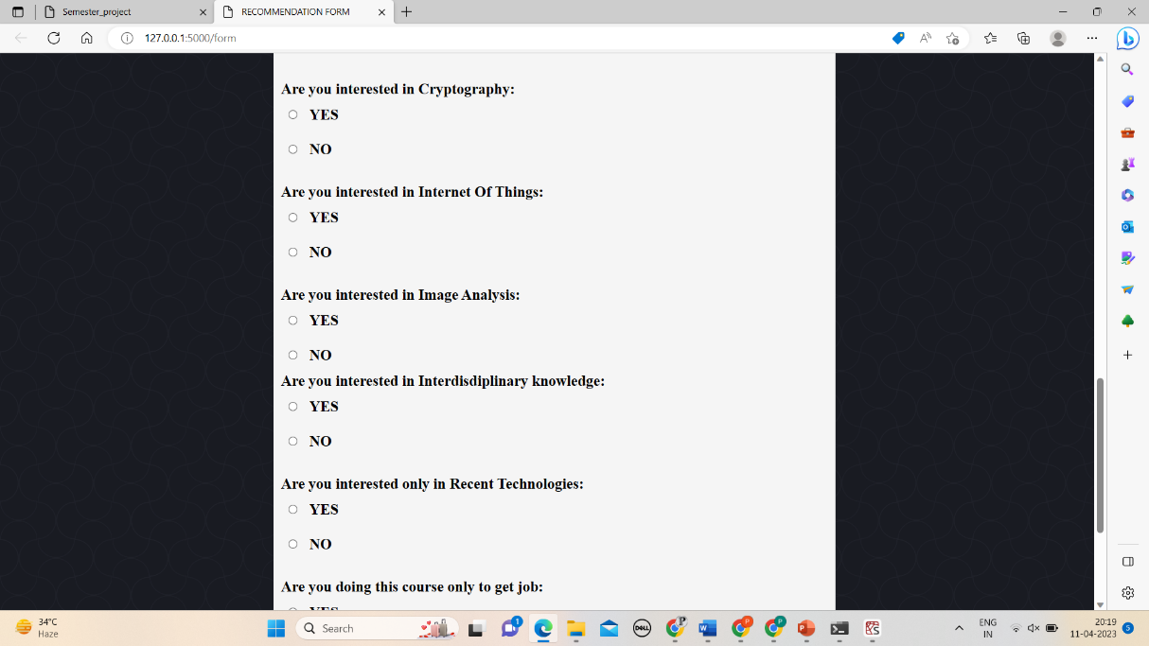

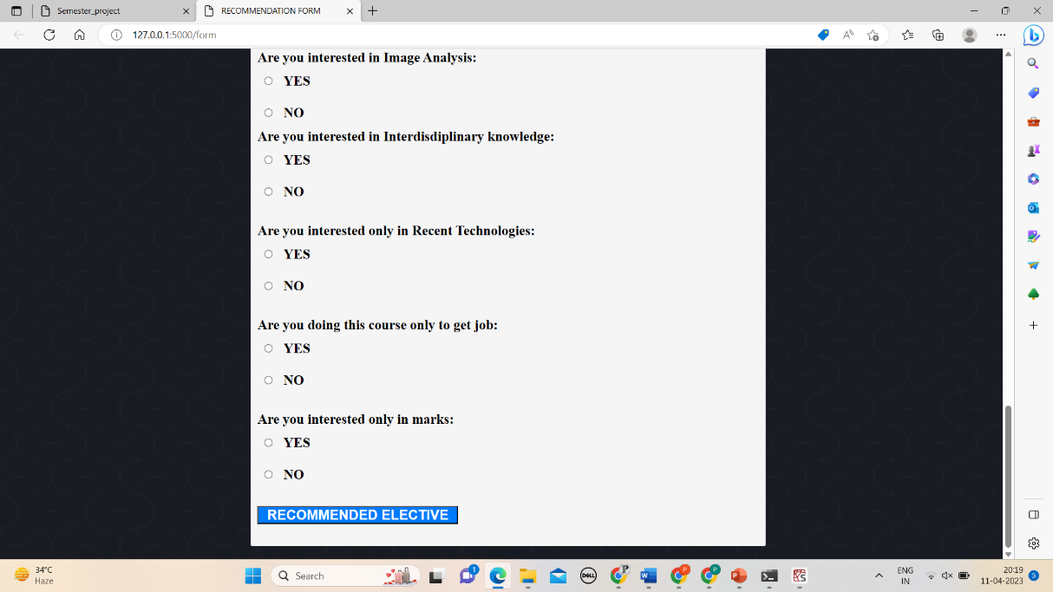

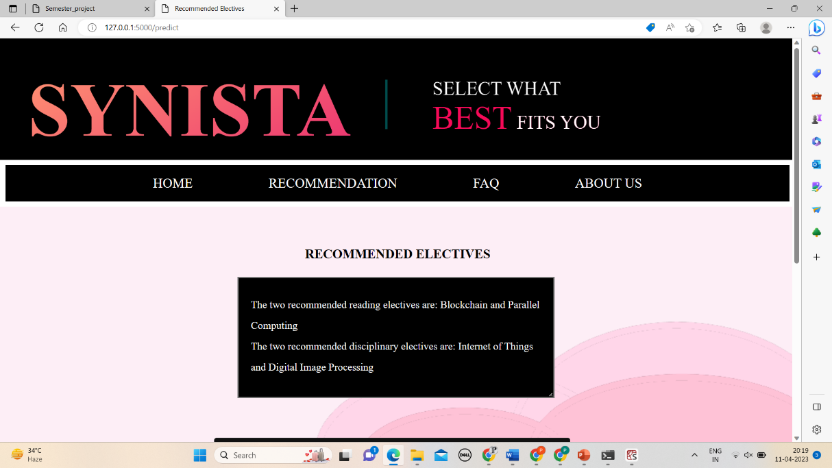

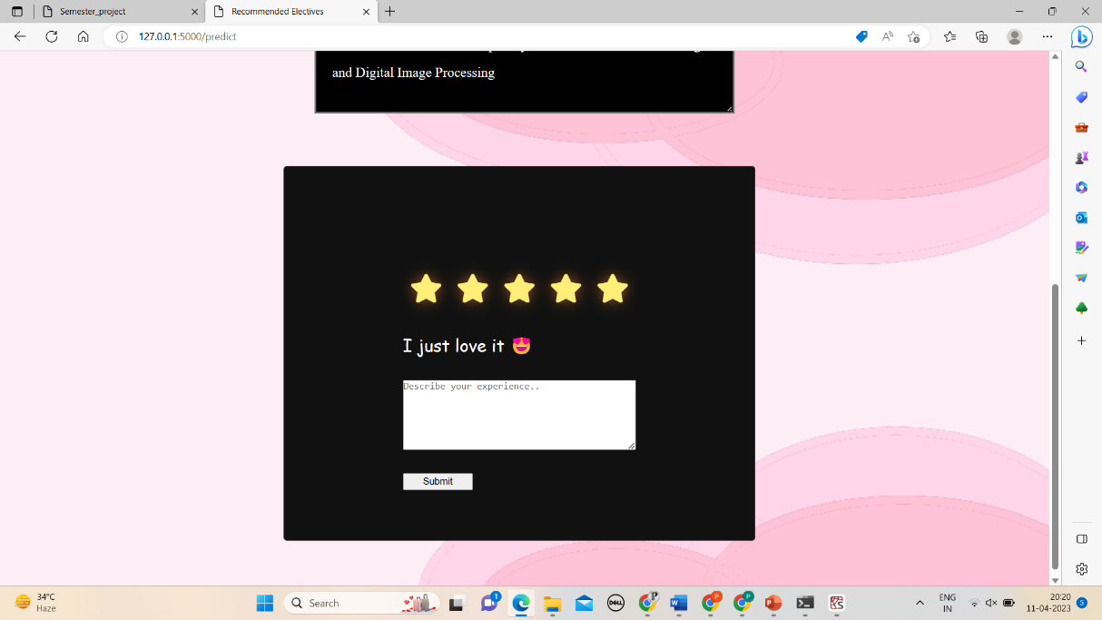

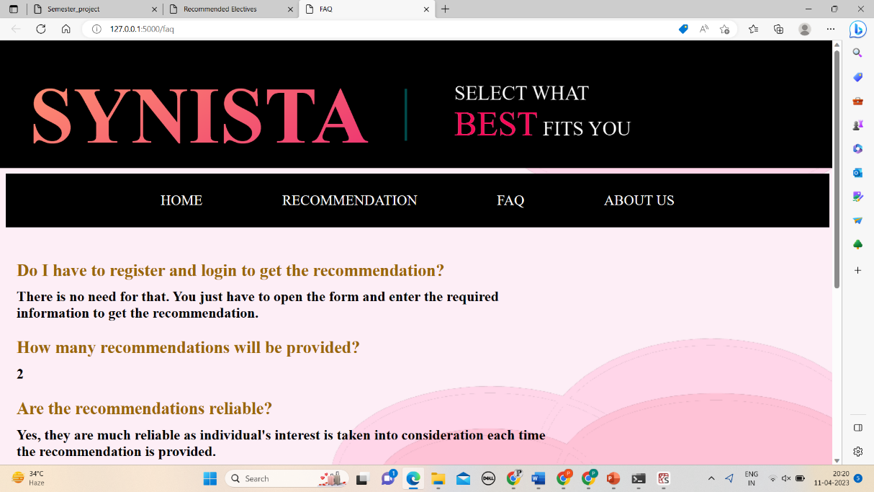

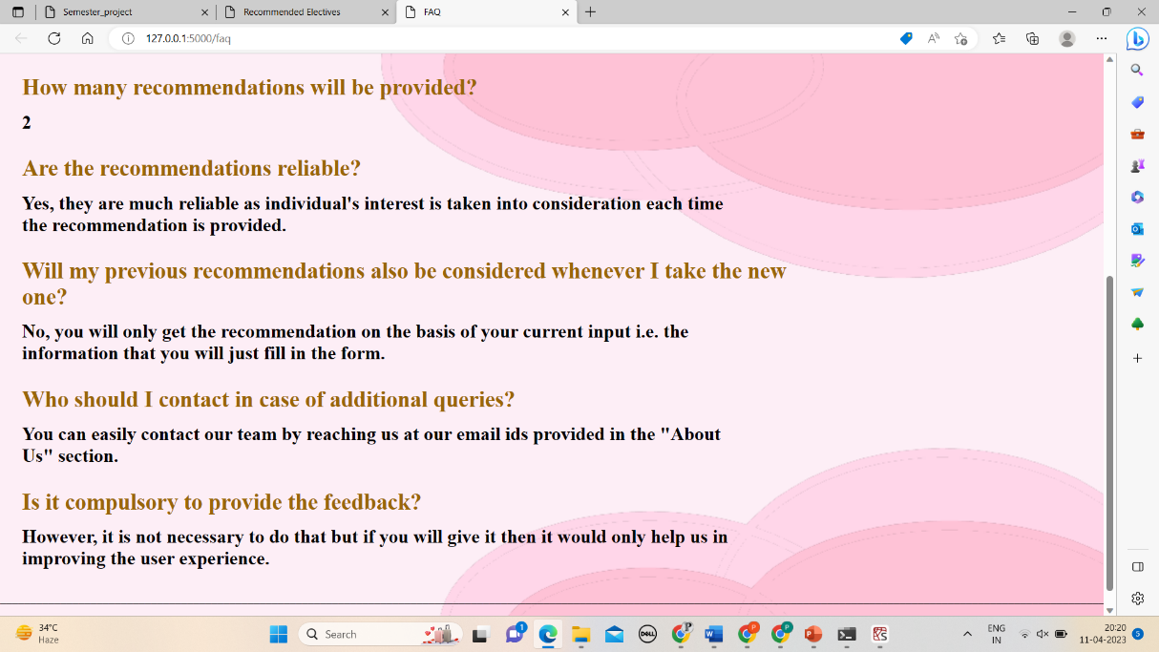

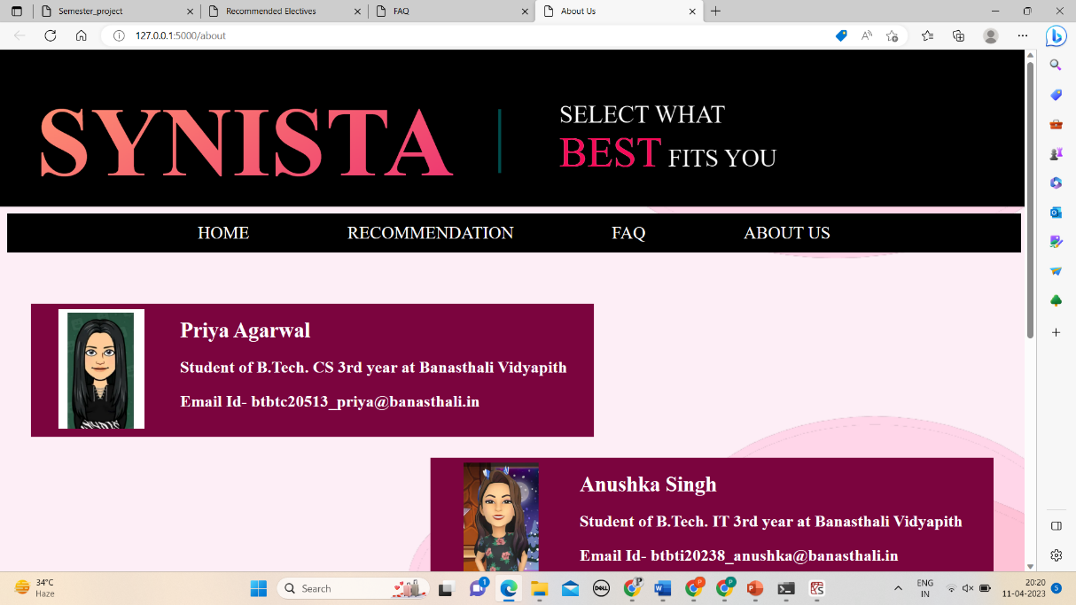

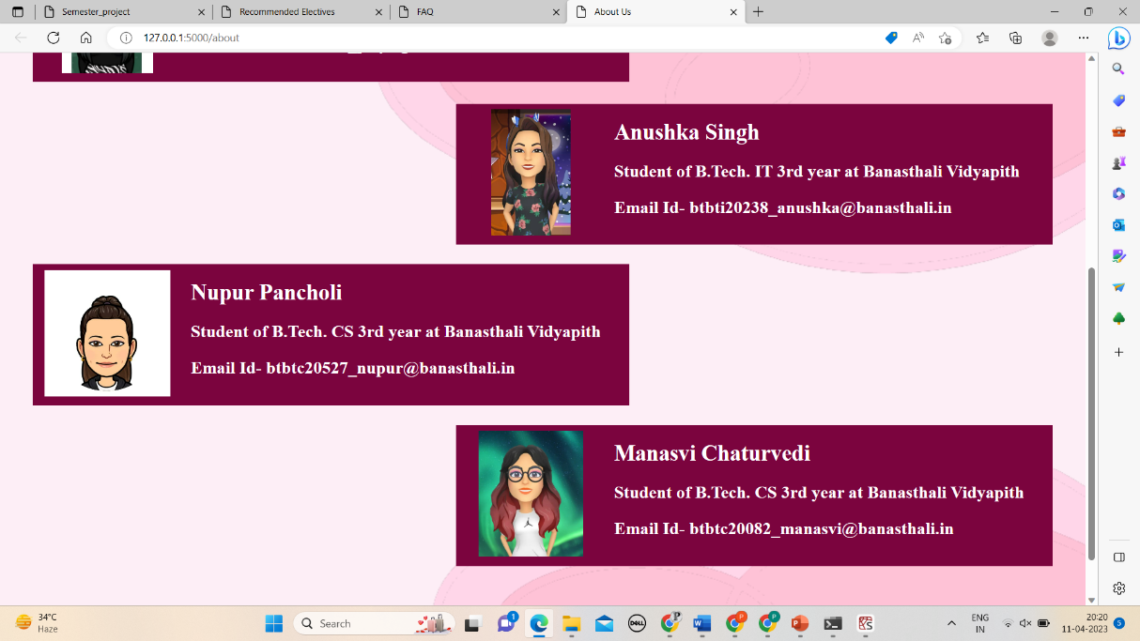

**APPENDICES**

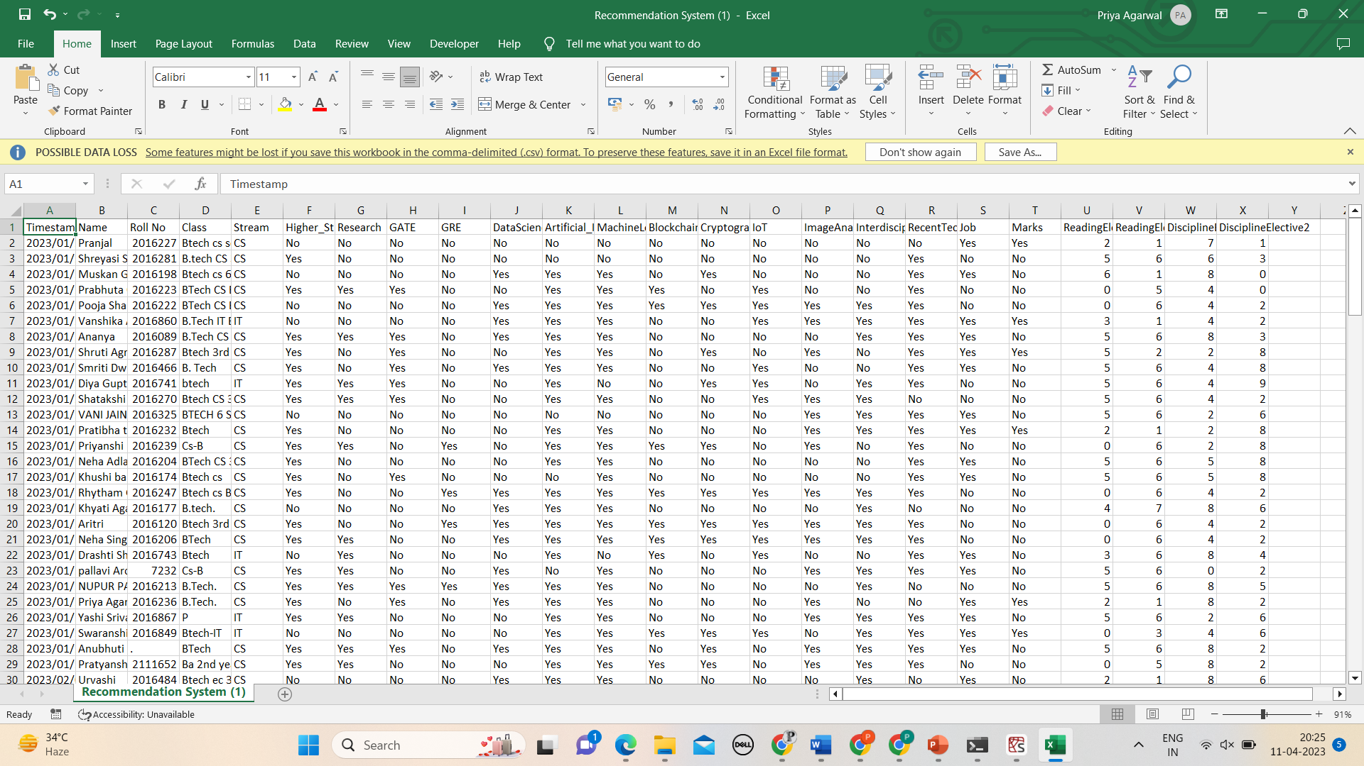

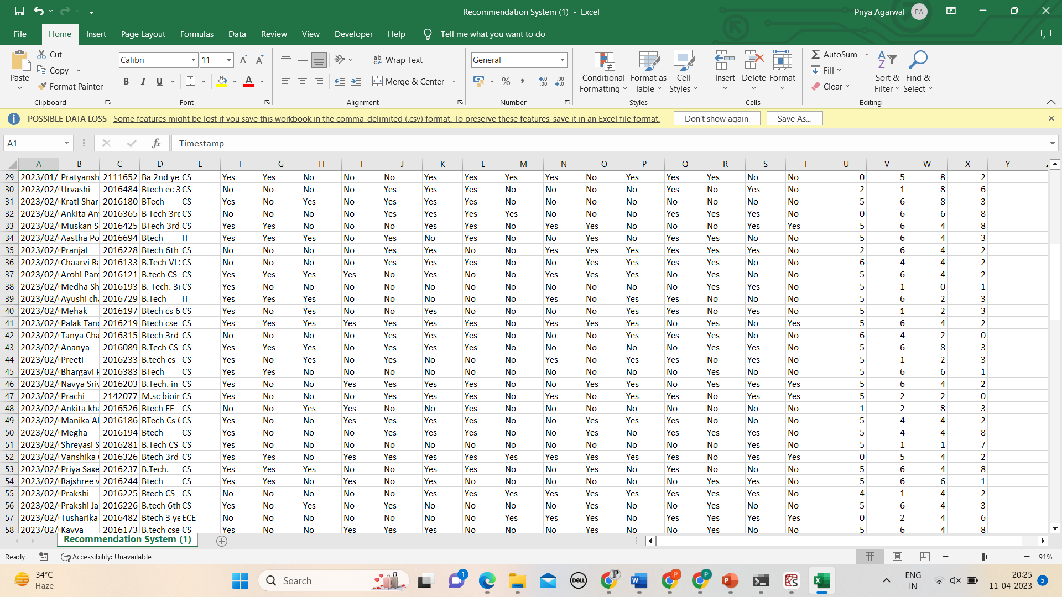

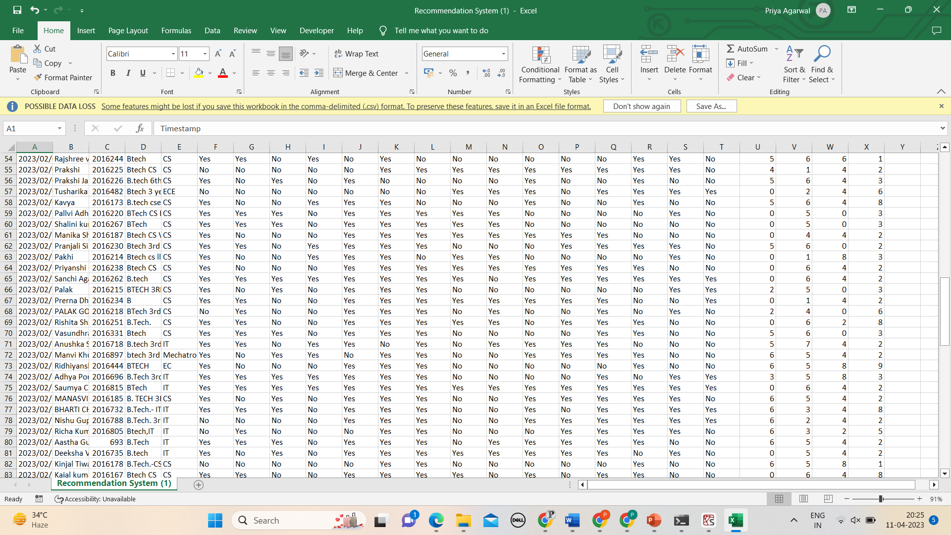

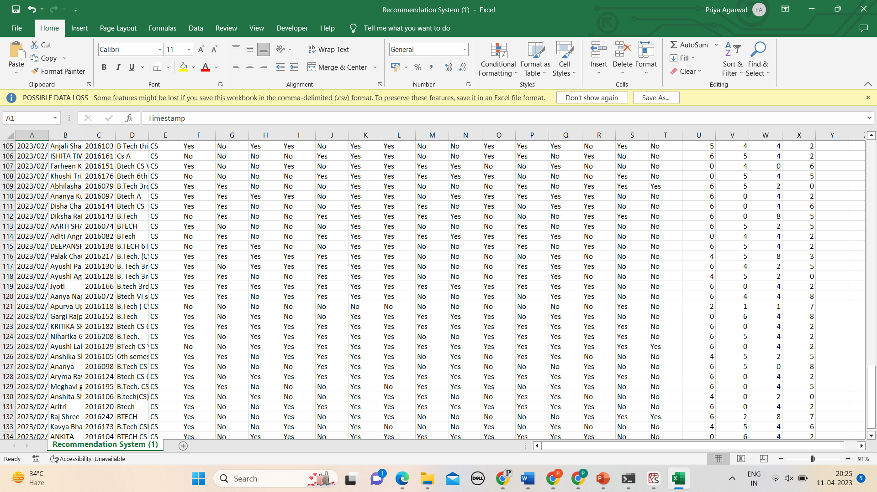

**REFERENCES**

* “IEEE Recommended Practice for Software Design Descriptions,” in IEEE Std 1016-1987, vol., no., pp. 1-16, 13 July 1987, doi: 10.1109/IEEESTD.1987.122643.
* E K Subramanian and Ramachandran, “Student Career Guidance System for Recommendation of Relevant Course Selection”, International Journal of Recent Technology and Engineering (IJRTE), ISSN: 2277- 3878, Volume-7, Issue-6S4, April 2019.
* Lakshmi Prasanna and D. Haritha, “Smart Career Guidance and Recommendation System”, International Journal of Engineering Development and Research, Volume 7, Issue 3, ISSN: 2321-993, 2019.
* ShivamMathwad, RushikeshPede, Aniket Chaudhari, Prashant Patil and Mr. Nikhil Dhavase, “Career Recommendation System”, International Journal of Engineering Development and Research, Volume 8, Issue 9, ISSN: 2394-2320, August 2021.
* Sunita B Aher and Lobo L.M.R.J., “Course Recommender System in ELearning”, International Journal of Computer Science and Communication, Volume 3, No. 1, pp. 159-164, January - June 2012.
* Eriya, P G Kodu, F Nugrahani and A Ghosh, “Recommendation System using Hybrid Collaborative Filtering Methods for Community Searching”, International Conference of Computer and Informatics Engineering, Conf. Series 1193(2019) 012021, doi: 10.1088/1742- 6596/1193/1/012021.

